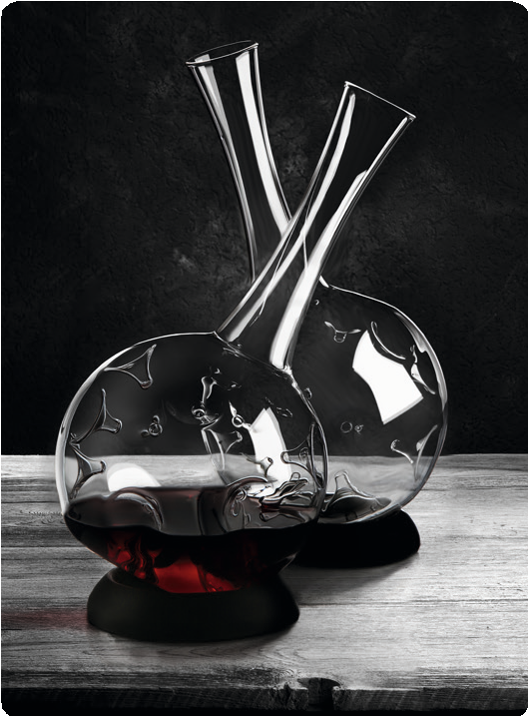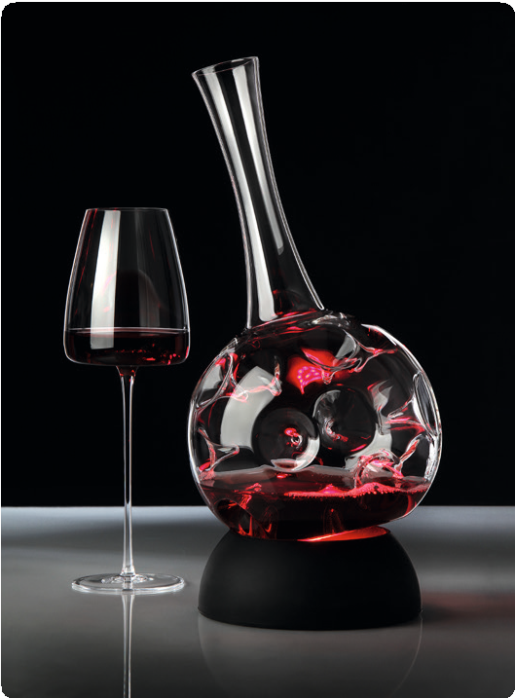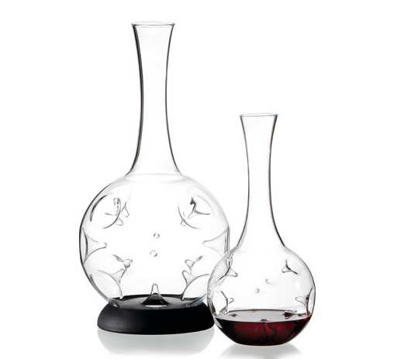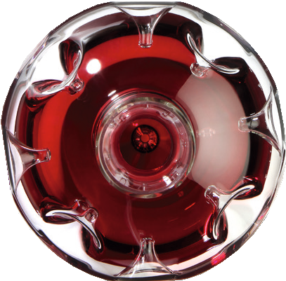“Eddy“ – breathe deeply!

The basic material for this development aid worker for wine is extremely robust and high-grade borosilicate glass. This type of glass, which stands out due to its dense structure, extraordinary transparency and hardness, is the precondition for the implementation of the introversive swirl elements. In an interplay with light and the contained wine, they create also visually interesting colour reflections and almost graphic effects.

”The decanter “Eddy” defines the world of extreme wine instruments in a completely new way. Their functionality has seldom been united with an aesthetic language of design in such a spellbinding way.

The matchlessly fast-paced development of structure, which all wines undergo in that respirator, is really fascinating! Once rotating in that texture stimulator they run within seconds, due to the thousandfold swirls at the conical indentations, through a process, which is equivalent to an oxidation reaction of several hours.”

Silvio Nitzsche - WEIN | KULTUR | BAR - Dresden

The volume of the big “Eddy” has been dimensioned in a way that, with a filling of up to 1,5 litres, the extension of the wine’s surface becomes as large as possible. Due to the flattened bottom, this respirator stands safely and straight, the enclosed collar made of matt black silicone also allows an inclined positioning.

The small “Eddy” is perfectly suitable for the decanting of wines by the glass or little bottles. Thereby the ideal charge to maximise the content of oxygen is 0,375 ltr. The compact design is perfectly suited to decant white wines first and then to temper in a wine cooler. By the extravagant character of these design elements, even high end cocktails and other exotic creations can be staged appropriately.

Design: Silvio Nitzsche

More information:

WWW.ZIEHER.COM

www.zieher.com/en/highlights/eddy/

03/2020
Zieher KG, Kulmbacher Straße 15, D - 95502 Himmelkron • marketing: +49 9273 9273-68 • presse@zieher.com
In our press area on www.zieher.com you will find all press releases including visual material to download.

