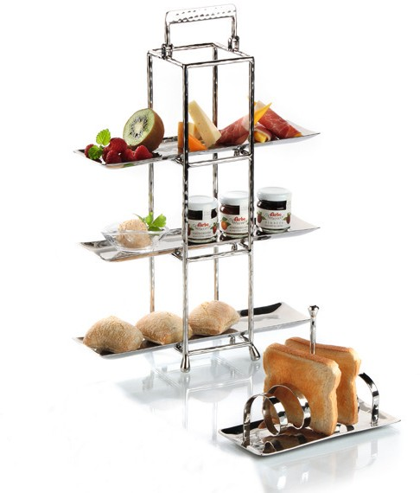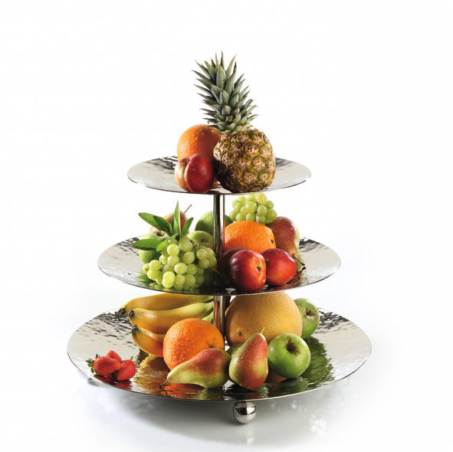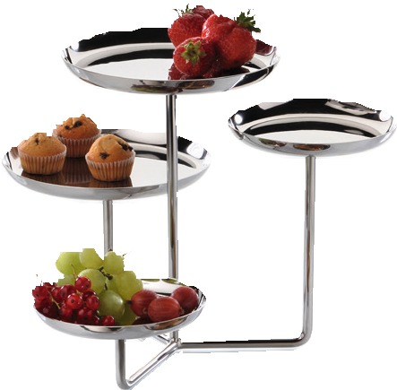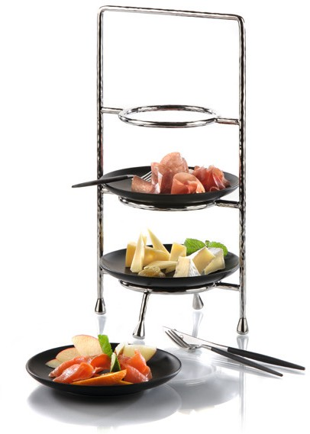Elegantly served - stylishly presented!

The beautifully shaped and individually designed etageres made of polished stainless steel present solutions for various applications.

Whether it is a two leveled etagere for snacks at the bar, a cubistic tower with removable trays or the 4-tier etagere with plates of different diameters, at ZIEHER you will get the perfect fit for every demand. Zieher offers in the range of etageres hammered as well as smooth models to meet everybody´s needs.

The classic mini format tiered servers with plates are available in two sizes. They effectively present petit-fours, desserts, chocolates or delicacies from the kitchen. Matt black or white plates made of high- quality porcelain create an interesting contrast to the hammered and highly polished stainless steel.

Whether it is five o‘clock tea, breakfast or finger food - etageres by Zieher offer a maximum use of minimum space.

WWW.ZIEHER.COM

03/2022
Zieher KG, Kulmbacher Straße 15, D - 95502 Himmelkron • marketing: +49 9273 9273-68 • presse@zieher.com
In our press area on www.zieher.com you will find all press releases including visual material to download.

