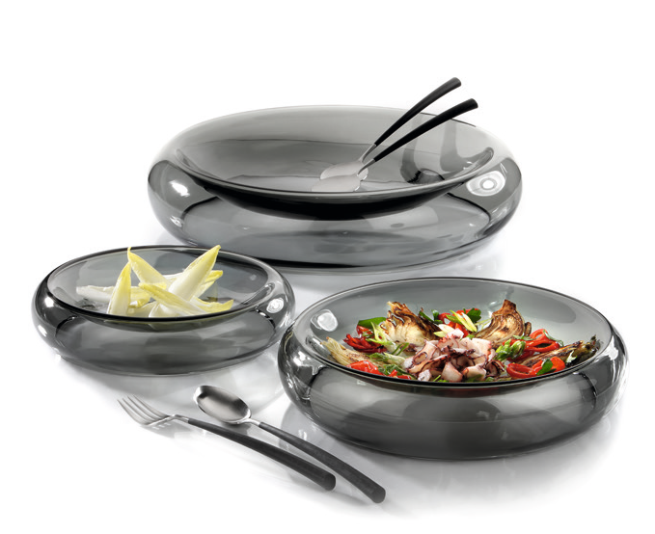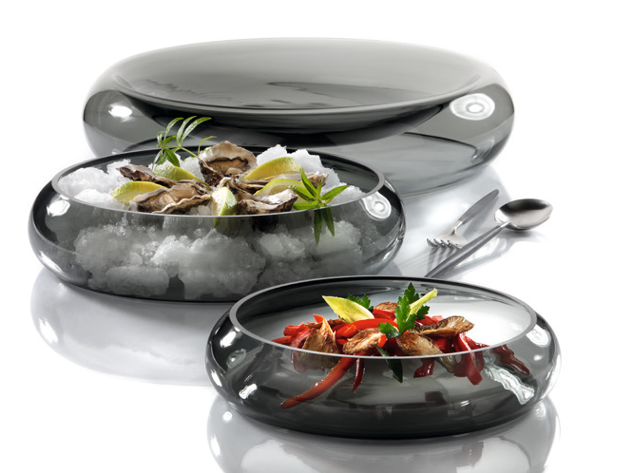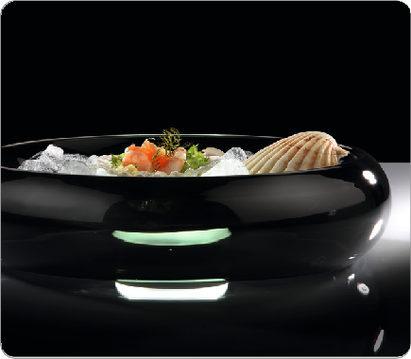“Duplex“ – unique pieces with double use!

The “Duplex“ series by ZIEHER consists of hand-blown bowls made of dyed-through grey glass. These hand-made, unique pieces
function as a decent background and present a harmonious frame for stylishly arranged foods.

Both sides of the bowls can be used. If the closed side is facing upwards, a smooth depression is created that can be used to present sophisticated dishes. When used the other way round more usable volume is generated, that is ideal for the filling with ice for example.

WWW.ZIEHER.COM

03/2022
Zieher KG, Kulmbacher Straße 15, D - 95502 Himmelkron • marketing: +49 9273 9273-68 • presse@zieher.com
In our press area on www.zieher.com you will find all press releases including visual material to download.

