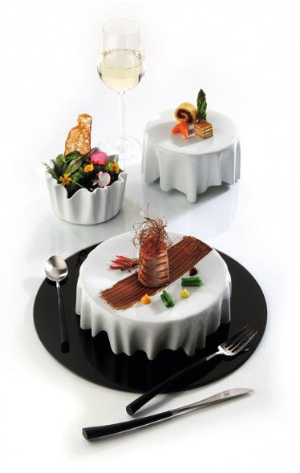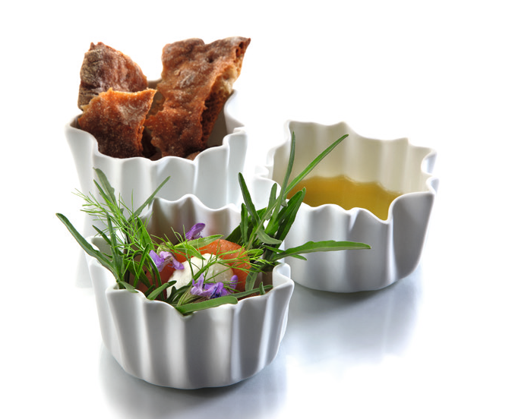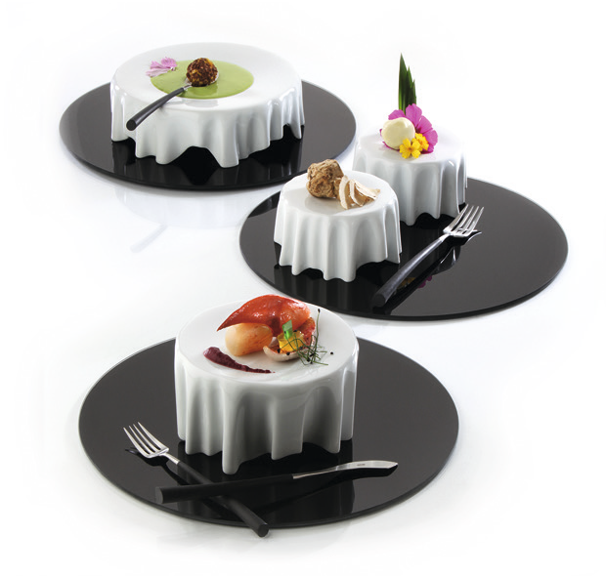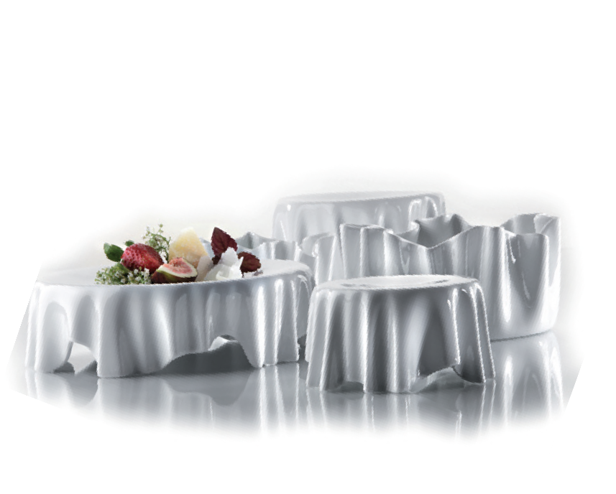“DressCoat“

The elegant language of design reminds of set tables, the creation of the plates respectively bowls is characterized by the apparently free falling drapery of table cloth which creates a seemingly weightless, almost floating effect.

A slightly concave shaped surface offers space for artful decorated dishes and avoids reliably the sloshing of sauce.

“DressCoat“ is available in various sizes. Besides the main application as plateau plate, each item of the “DressCoat“ series may also be used as bowl. The falling folds add up to an exciting game of shapes – in particular if used as a bowl!

With “DressCoat“ you will dish up delicacies!

Design: glass and porcelain designer Nadine Podewski

WWW.ZIEHER.COM

03/2022
Zieher KG, Kulmbacher Straße 15, D - 95502 Himmelkron • marketing: +49 9273 9273-68 • presse@zieher.com
In our press area on www.zieher.com you will find all press releases including visual material to download.

