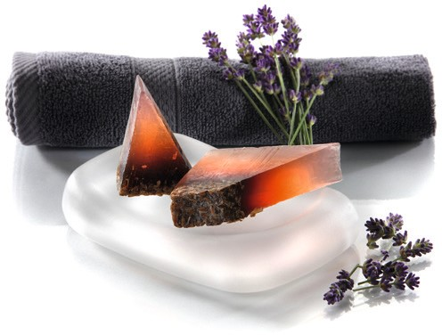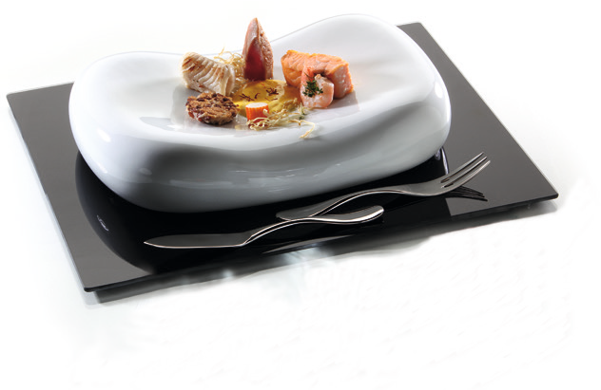“Donna“ – bedded extravagantly

The shapely pillows “Donna“ by Zieher, which are based on the curved back of a woman, are certainly not suitable for sleeping, but they offer the ideal presentation surface for top creations. Available in two versions, “Donna“ stages every dish and surprises the guest with its extraordinary shape. The organic shaping of these allows for several different uses, the small “Donna” pillow may even be used as a soap dish.

On the porcelain version of “Donna“, hot dishes are kept warm – this is due to the radiant heat that the double-walled porcelain design product still emits over a considerable period of time.

Especially the small pillows made of satined glass can be perfectly used on the buffet and offer an exciting contrast to conventional forms.

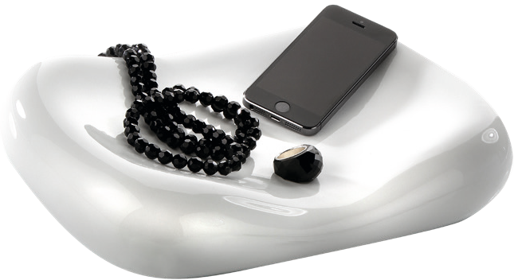The softly curved shapes of this hand flatterer simply have to be touched.

As an extraordinary plate, fruit bowl, place to keep accessories or as a sculptural decoration, each “Donna“ cushion seduces with the charm typical of the respective material.

Design: Wilma Greim

WWW.ZIEHER.COM

03/2022
Zieher KG, Kulmbacher Straße 15, D - 95502 Himmelkron • marketing: +49 9273 9273-68 • presse@zieher.com
In our press area on www.zieher.com you will find all press releases including visual material to download.

