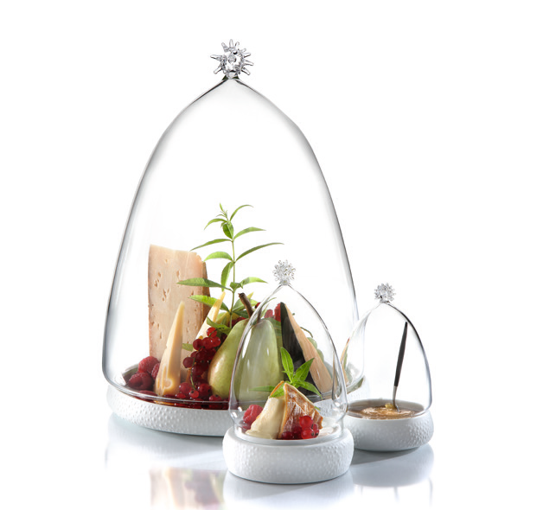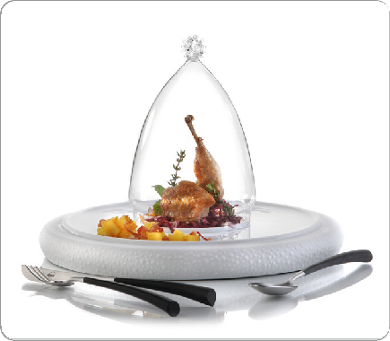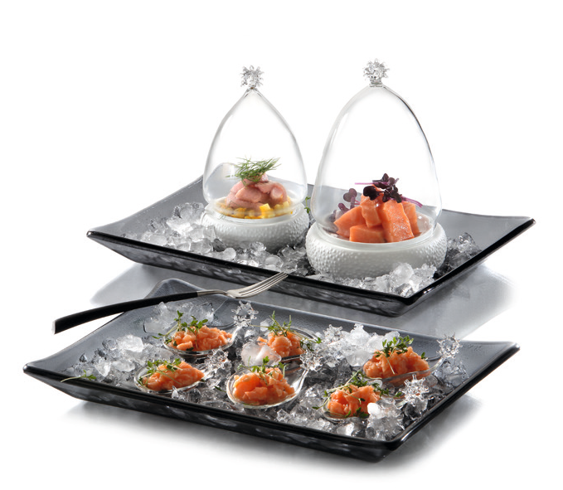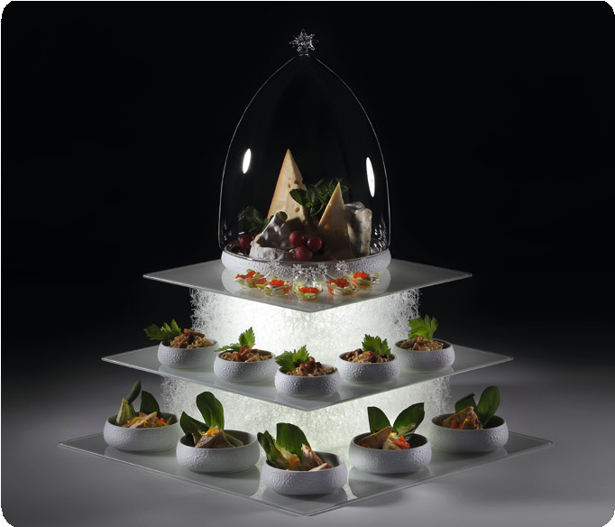“Cuspis” – Borosilicate glass in its most beautiful shape!

The primary design element of the series “Cuspis” is a glass ball studded with fine spikes.

The filigree cloches with a fitting base made of porcelain are available in three sizes and the inspiration for their shaping was derived from the nut of the oak tree. The ball-shaped handle is located at the top of the cloches and allows for an uncomplicated handling of these classy covers.

The unglazed outside of the porcelain bowls and plates with its distinctive texture is reminiscent of acorn caps. The bowls can be used on both sides. When used as a plateau plate, the dishes
move closer to the guest while the filigree glass cloche protects the presented delicacies and puts them in the limelight at the same time. Used as a bowl, it offers space for gravies, sauces and more.

Design: Michael Schwarzmüller

WWW.ZIEHER.COM

03/2022
Zieher KG, Kulmbacher Straße 15, D - 95502 Himmelkron • marketing: +49 9273 9273-68 • presse@zieher.com
In our press area on www.zieher.com you will find all press releases including visual material to download.

