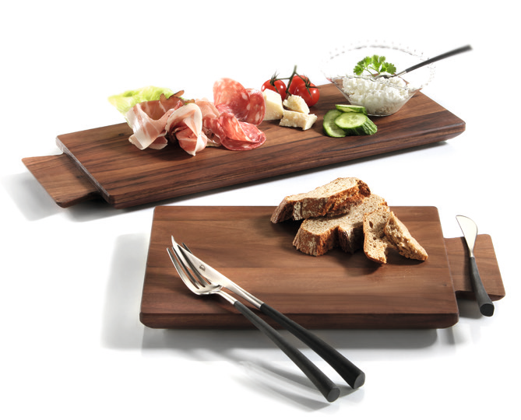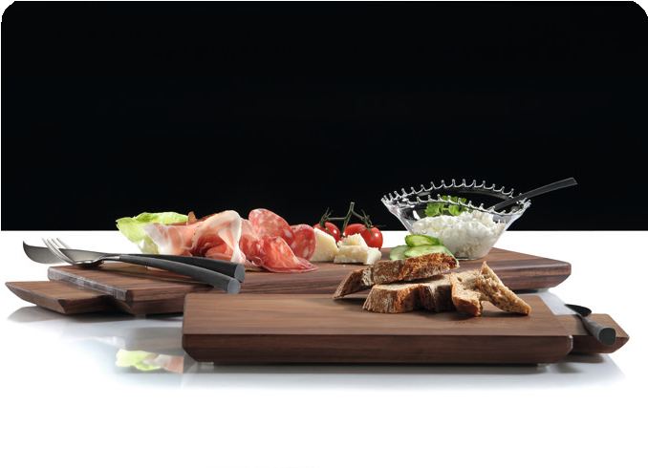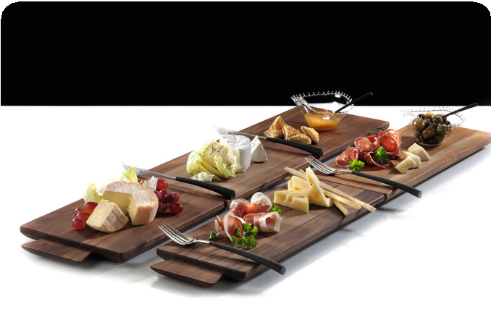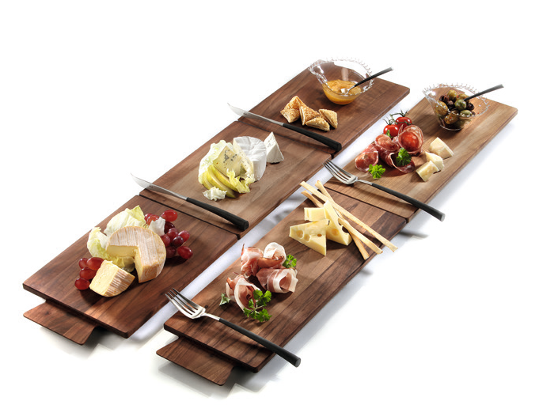“Connect! “– serving platters made of walnut!

Noble in their charisma, unadorned in design, practical by compact formats and highly functional in combination - the solid wood boards of the series “Connect!” convince as a snack board, serving and cutting board, or by combining several elements to form a presentation platter, “Connect!” is an extremely versatile tool for everyday use.

The integrated tenon in the shape of a dovetail serves as a decorative handle with a craftsmanship style. “Connect!” is available in two versions. Shape and size of handles and cutouts on the underside allow an easy combination of different elements and versions. Skid-proof positioning feet ensure a firm stand, the slanted outer edges facilitate handling.

The solid walnut wood is sealed with high-quality oils. In case of traces of everyday wear and tear this surface can easily be freshened up.

DESIGN Oliver Zieher

WWW.ZIEHER.COM

03/2022
Zieher KG, Kulmbacher Straße 15, D - 95502 Himmelkron • marketing: +49 9273 9273-68 • presse@zieher.com
In our press area on www.zieher.com you will find all press releases including visual material to download.

