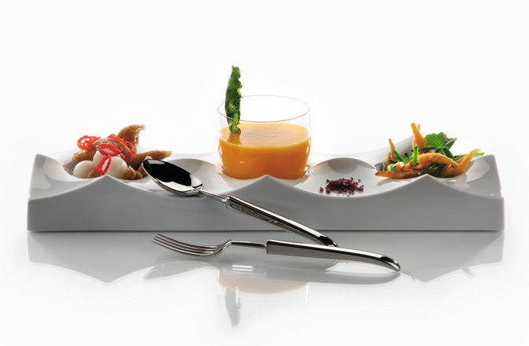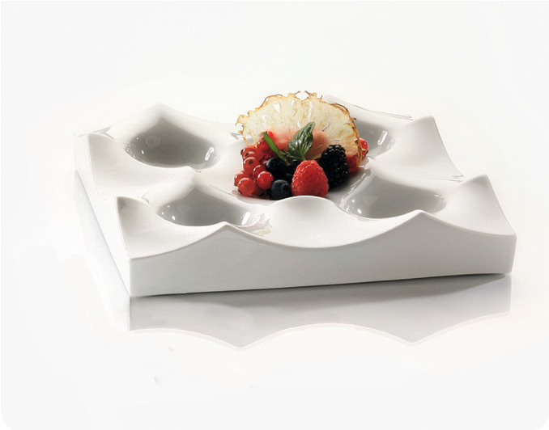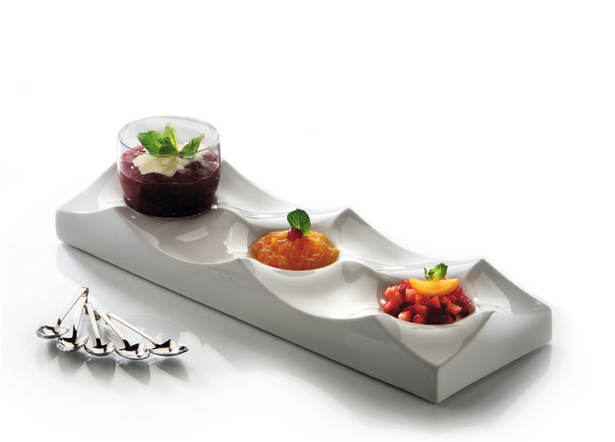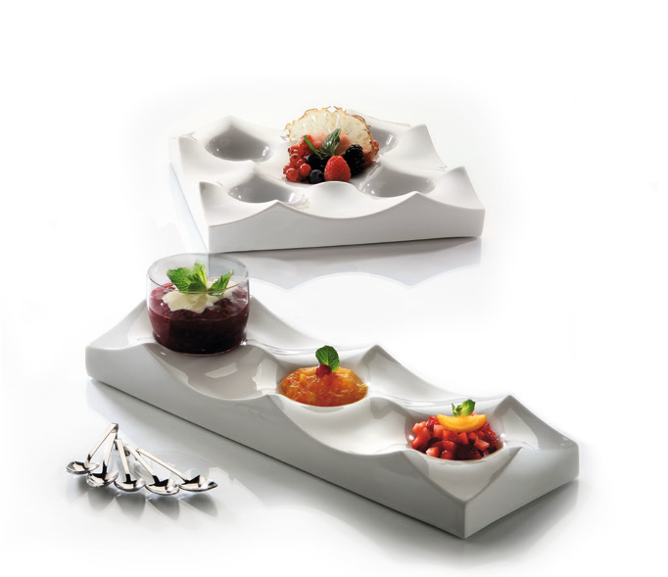“Collina“ - The hill country!

The translation for the Italian word “Collina” is “the hill” or “hill country”. This evokes hills or dunes which rise regularly next to each other, or valleys and hollows which are separated by ridges.

Designer Wilma Greim is the composer of “Collina” and has already created the “porcelain cushion” “Donna” for Zieher.

The rigorously geometrical structure makes it possible to string together several plates which allows extensions in both length and width.

When looking at the surface from the side, the arrangement still appears like a desert landscape arbitrarily formed by the wind. “Collina” enables many an applicability. If it is in the lobby or on the buffet, for the presentation of fruit or pastry, or as an exclusively decorative element, this series is versatile.

A selection of fruit can be put in the limelight with the hollows of this plates.

But the possibilities when considering private use are numerous, too. Next to using “Collina” as a fruit bowl, one can always convert the plate to a place for objects of everyday life, such as the mobile phone or keys.

In order to protect the sensitive surfaces of furniture, every plate comes with feet made of sponge rubber which can be stuck on when needed.

Design: Wilma Greim

WWW.ZIEHER.COM

03/2022
Zieher KG, Kulmbacher Straße 15, D - 95502 Himmelkron • marketing: +49 9273 9273-68 • presse@zieher.com
In our press area on www.zieher.com you will find all press releases including visual material to download.

