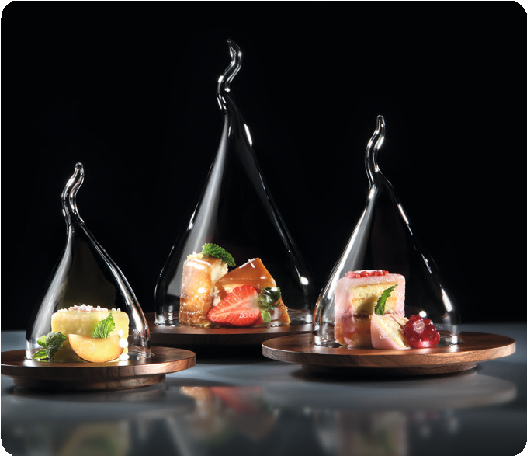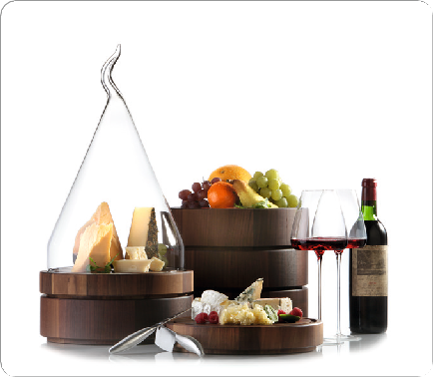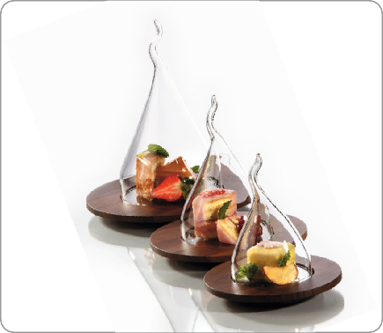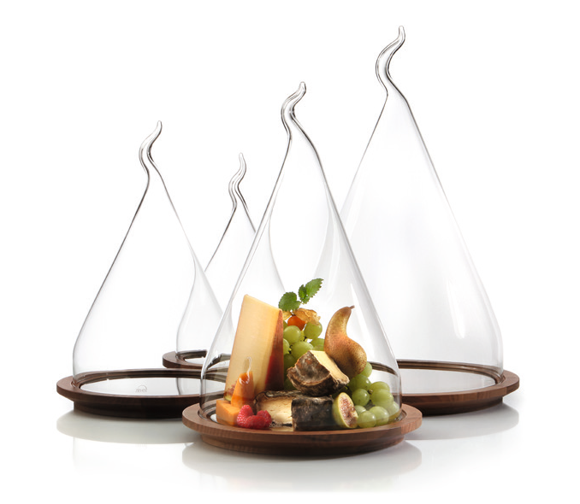„Cloches of some other kind“

The glass cloches by ZIEHER, which are meanwhile available in various sizes (diameter 9cm to 30cm), delight by their unusual form! The presentation of fine truffles, an exclusive choice of cheese or just simply a single praline – there is a fitting size for each purpose.
The light cloches by ZIEHER are heat resistant, dishwasher safe and very easy to handle for the guests. Each item is hand-blown, manu- factured by hand and therefore also slightly different and individual!

The raw material for these items is borosilicate glass, which is mainly used for laboratory dishes. Its main features are a great resistance against heat and changes in temperature, as well as a high break resistance.

WWW.ZIEHER.COM

03/2022
Zieher KG, Kulmbacher Straße 15, D - 95502 Himmelkron • marketing: +49 9273 9273-68 • presse@zieher.com
In our press area on www.zieher.com you will find all press releases including visual material to download.

