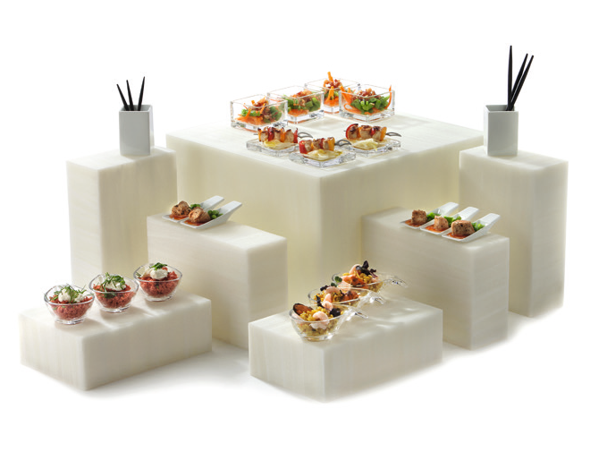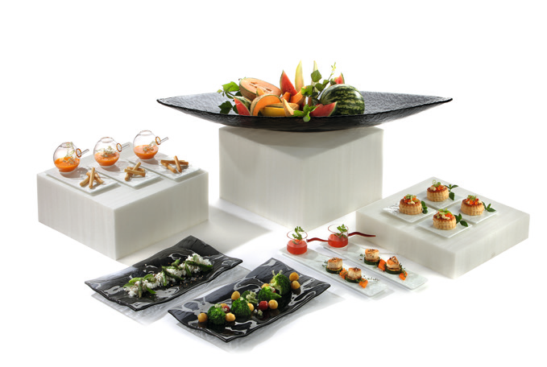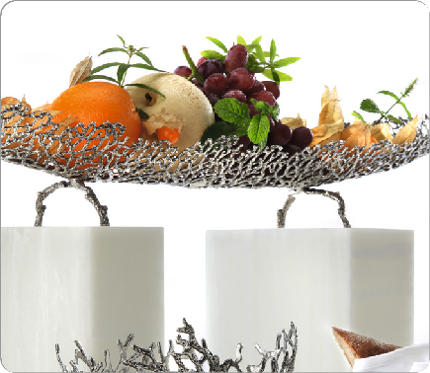”On the rocks“ reinterpreted - ”Classy“ by ZIEHER

The buffet displays ”Classy“ are made of translucent material and impress by their fascinating texture that evokes Italian marble or alabaster. The precise workmanship of the cuboids as well as the silk-matt surface increase the fancy impression even more.

“Classy” is available in the ZIEHER-system-heights of 8, 16 and 24 cm and can therefore be combined in various ways. The open un- derside of the larger displays allows an effective illumination by the optionally available ZIEHER LED-lights. With their different light co- lours, the appealing look and the interesting marbling of the material is emphasized.

The small cuboid is closed on all sides and thus can not be illumina- ted. The advantage of this construction lies in the high functionality of the item. Its measurements of 24 x 16 x 8 cm allow the positioning in three heights, a clever addition to the square displays.
It is partially possible to stage “Classy” with or without lighting, strikin- gly eye-catching or quite decently. Whether unobtrusive and modern or playful and opulent – “Classy” fits perfectly into every into any surroundings.

WWW.ZIEHER.COM

03/2022
Zieher KG, Kulmbacher Straße 15, D - 95502 Himmelkron • marketing: +49 9273 9273-68 • presse@zieher.com
In our press area on www.zieher.com you will find all press releases including visual material to download.

