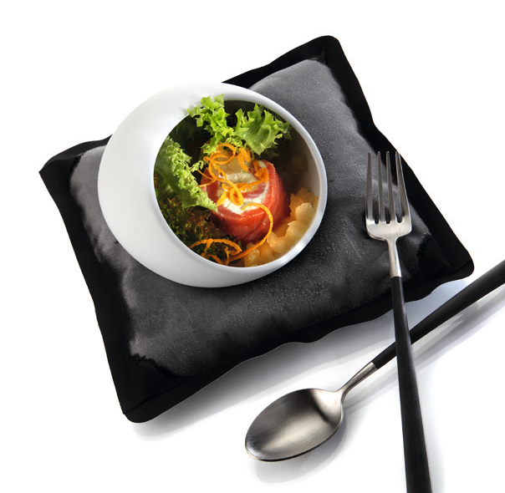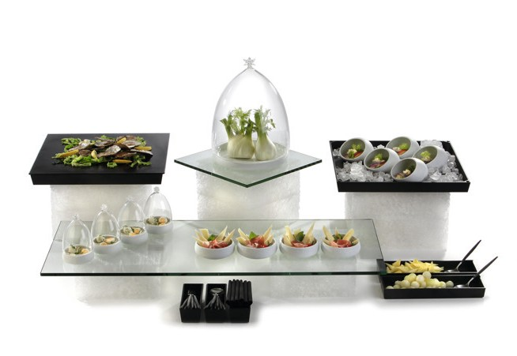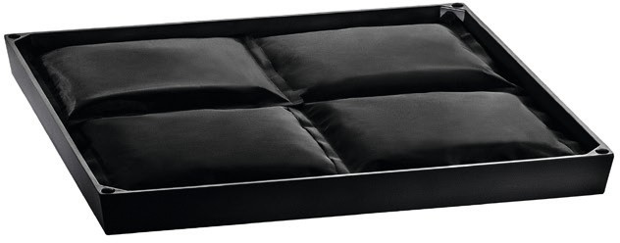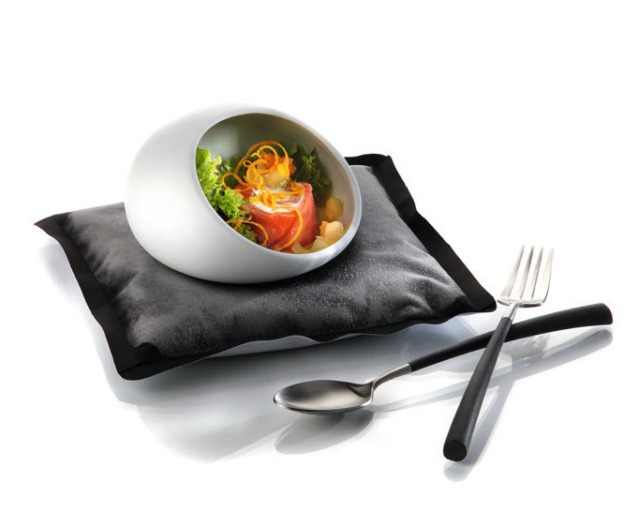“Chiller-Base” – just stay cool!

The cooling elements by Zieher are an elegant and simple solution for a quick and flexible installation of chilled platters. They can be arranged either at different heights by using displays or freely positi- oned on the buffet table.

The flat bowls are available in matt black and white melamine and have been designed specifically for food whose presentation can be extended significantly by cooling.

The puristic form, the compact height of only 35 mm as well as the restrained colouring allow a stylishly discreet integration into nu- merous buffet constructions. Tailored recesses on the underside of the trays facilitate symmetrical positioning on most Zieher buffet systems. So a harmonious overall picture can be achieved quickly.
Unobtrusive rubber buffers in the corners of the „Chiller-Base“ ensure a non-slip and secure fit of laid-up platters in sizes starting from 42 x 42 cm.

The cooling pads have been tailor-made for the melamine base to provide for an optimal cooling surface by the perfect fit. The pads can optionally be flipped, depending on whether the black top or the white bottom fits into the overall picture more harmoniously. So they are applicable inconspicuously even with slightly translucent or sati- ned buffet platters.

The attractive contrast of top and bottom can also be used on the laid table to deliberately set accents. Serving chilled foods becomes a visual highlight.

The high-quality case made of black or white nylon fabric looks very noble and yet discreet. It is filled with gel, which remains malleable even when frozen and thus allows and adaptation to a wide variety of tableware used.

WWW.ZIEHER.COM

09/2020
Zieher KG, Kulmbacher Straße 15, D - 95502 Himmelkron • marketing: +49 9273 9273-68 • presse@zieher.com
In our press area on www.zieher.com you will find all press releases including visual material to download.

