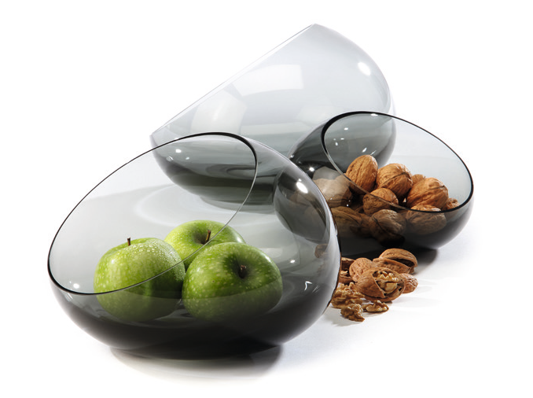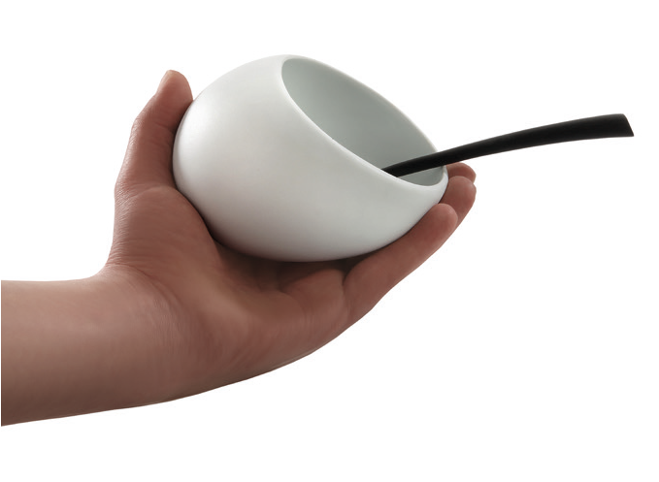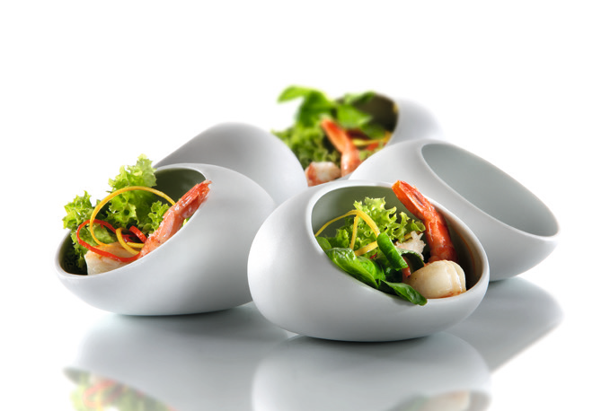“Cave” – pearls of the south sea

Like the shell hides the pearl, the porcelain miniature “Cave” conce- als precious delicacies within its hard shell. This porcelain piece at first sight only partly reveals its interior. “Cave” consists of intricately worked hard porcelain and captures by its soft shape and the velvety haptics of the unglazed outside. Touching the cave-shaped bowl it feels almost like a palm stone made of white gold, having a soft ap- pearance with delicious contents.

“Cave” is predestined for a use at cocktail and hors d‘oeuvres recep- tions or at the flying buffet. The miniature bowl can be carried com- fortably and perfectly fits in the palm of the hand.

The glass versions of the “Cave” bowl are available in two sizes. The soft tinge of this grey glass, which is manufactured in a traditional hand-blowing process, emphasizes the content of these shapely objects.
They offer the fitting framework for fruit, nuts and nibbles as well as for tastefully arranged pasta or salad on a solemnly decorated table. The content of the bowls remains protected by the shell of glass, the amply dimensioned opening seduces to snap at a chance. These unique items enthuse as well as a place to keep all kinds of accesso- ries.

Design: Wilma Greim

WWW.ZIEHER.COM

09/2020
Zieher KG, Kulmbacher Straße 15, D - 95502 Himmelkron • marketing: +49 9273 9273-68 • presse@zieher.com
In our press area on www.zieher.com you will find all press releases including visual material to download.

