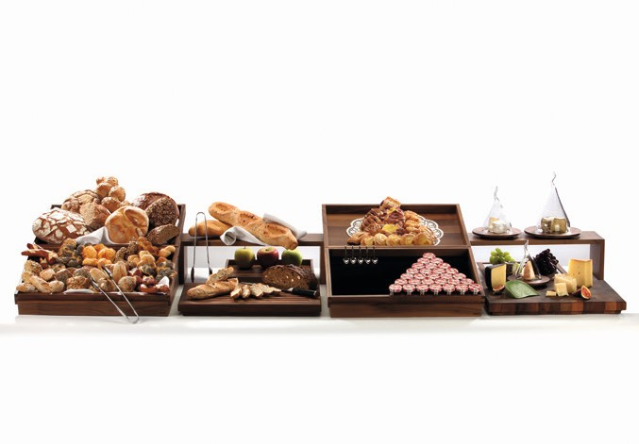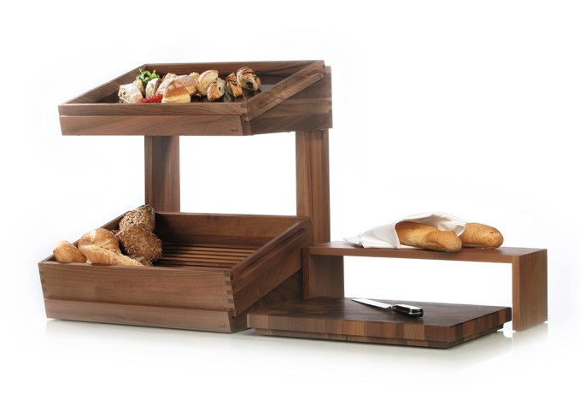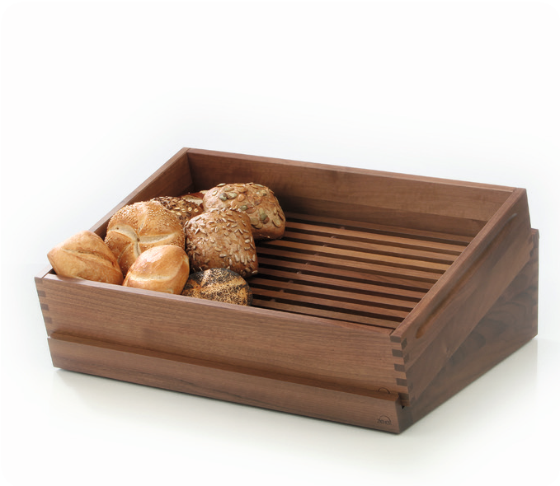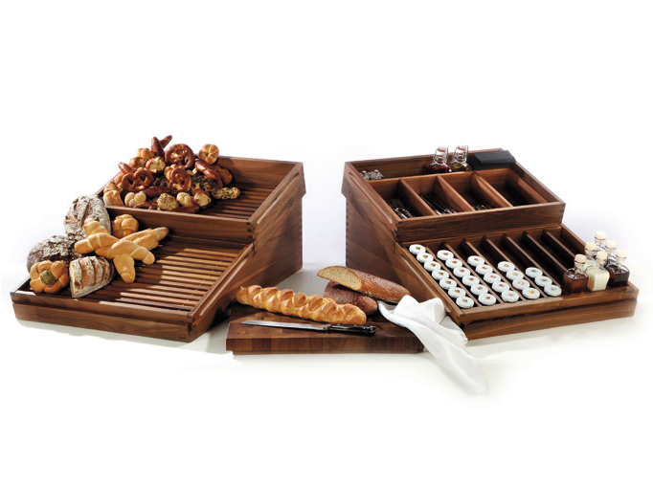„Solid“- Bread and more, attractively presented on the buffet!

The presentation of bread is not only important at the table; on the breakfast buffet too, the variety of baked goods wants to be put in the proper limelight.

The Zieher – buffetsystem with its oblique displays for wooden trays allow for a clear arrangement of various types of bread. The existing display for two trays has been complemented by a shorter version, which offers room for one tray. With the help of a connector piece, two of these tray displays may be stacked and used on top of each other. The ideal solution for small buffet tables. A fitting cutting board including a crumb drawer and an exchangeable grate, a cutting board made of end grain wood as well as various bridges complete the series and provide the healthy and diversified breakfast with a new look.

Next to the already known bread tray a novelty can be found: a deeper version that is suited specifically for the presentation of rolls, buns, biscuits and pastries. A removable grate provides air circulation, freshly baked buns remain scrumptious longer.

Two kinds of divisions (for the tray) offer space for several miniatures and allow for a flexible use of the system. A cutlery insert for the deep tray, as well as an insert for slices of toasted bread round off the range.

Massive wood from the walnut tree, which is one of the most precious and most beautiful types of wood, forms the basis for the serie “Solid” by Zieher. Both the wood`s warm brown colours in different shades and its intensive and distinctive grain make every product a unique item!

Zieher guarantees high durability even in everyday use due to highest-quality craftmanship and food-safe sealing.

WWW.ZIEHER.COM

03/2022
Zieher KG, Kulmbacher Straße 15, D - 95502 Himmelkron • marketing: +49 9273 9273-68 • presse@zieher.com In our press area on www.zieher.com you will find all press releases including visual material to download.

