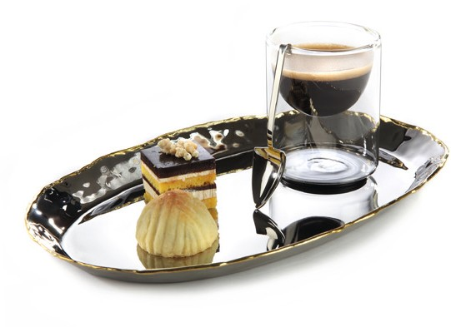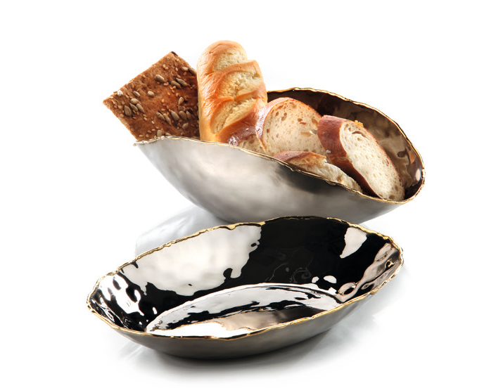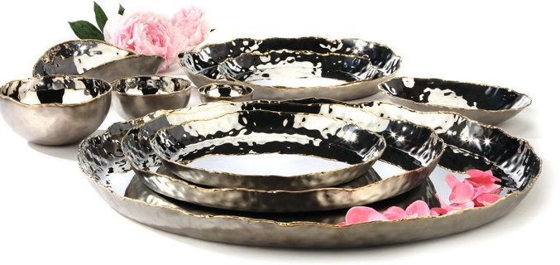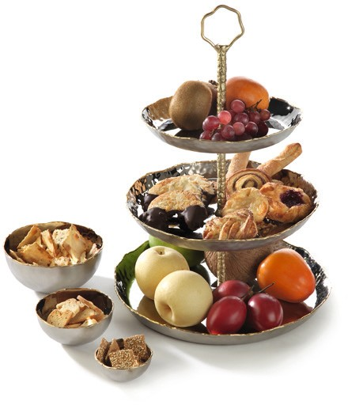“Artisan“ by ZIEHER- craftsmanship with artful edge

The trays and bowls of the “Artisan“ series are fascinating and diver- sified at the same time. The inside with its perfectly polished surface creates an interesting contrast to the matt outside.

The handcrafted rim impresses by its irregularity and is crowned by a circumferential brass edge. The combination of hammered and plain surfaces, of massive stainless steel and brass, awards that series a certain something.

“Artisan” is a series of contrast!

Various round and oval bowls as well as trays in various sizes are created by elaborate craftsmanship, thus making every part of the range unique.

Due to the different available sizes, „Artisan” is perfect for waiting, no matter whether espresso and snacks or regular coffee is served.
The plane surface of the trays facilitates the service and prevents unpleasant noise. When used at the buffet, creatively arranged food can be presented appealingly and is accentuated by the reflection of the polished surfaces.

WWW.ZIEHER.COM

09/2020
Zieher KG, Kulmbacher Straße 15, D - 95502 Himmelkron • marketing: +49 9273 9273-68 • presse@zieher.com
In our press area on www.zieher.com you will find all press releases including visual material to download.

