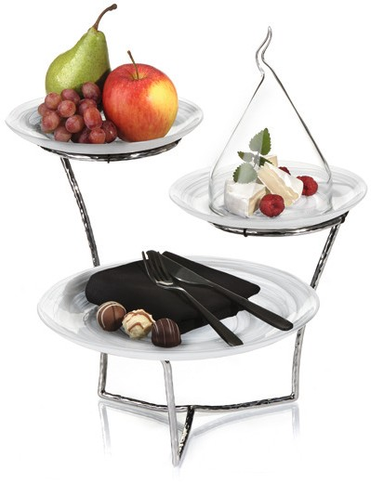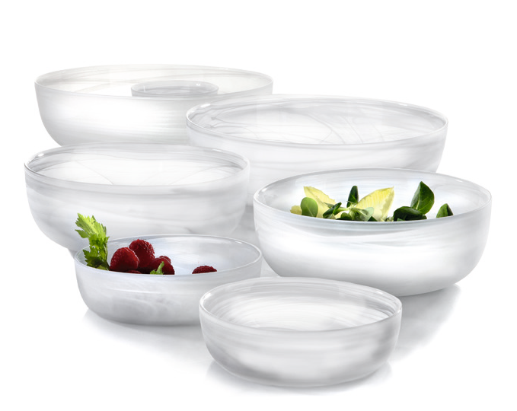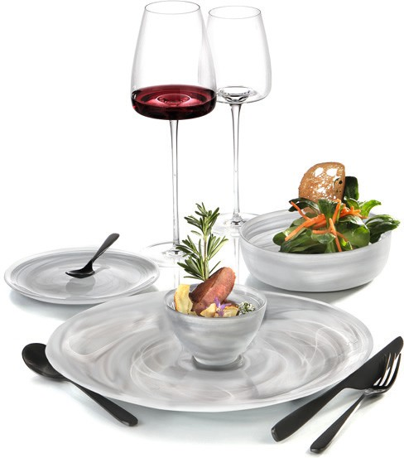“Unique“ – glass plates and bowls

The plates and bowls of the “Unique“ series are made of clear glass, which is awarded an inimitable character by adding white glass components. This creates individual streaks and swirls, which assemble to highly exciting patterns. The underside of the plates as well as the outside of the bowls are blasted, which results in satined optics and pleasant haptics.

“Unique” presents - in shape and decor - a real counterpart to the uniform character of industrially manufactured mass products and proves to be as unique as its users

“Unique” is produced in centrifugal casting. Besides the individual decor, this production method entails a slight variation of size, strength and shape of the items, also some air inclusions are possible. That’s exactly what awards these unique pieces their special charm.

WWW.ZIEHER.COM

03/2022
Zieher KG, Kulmbacher Straße 15, D - 95502 Himmelkron • marketing: +49 9273 9273-68 • presse@zieher.com
In our press area on www.zieher.com you will find all press releases including visual material to download.

