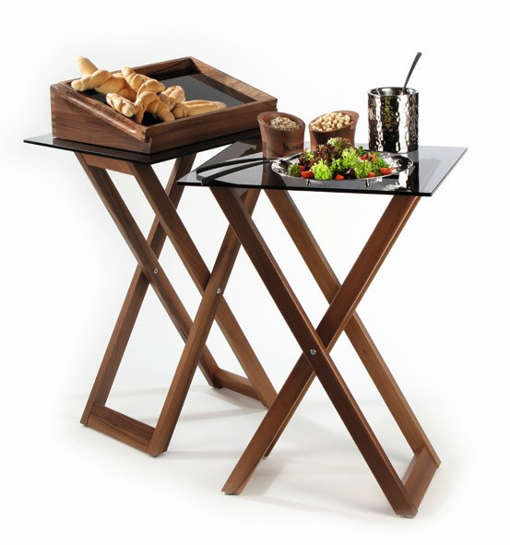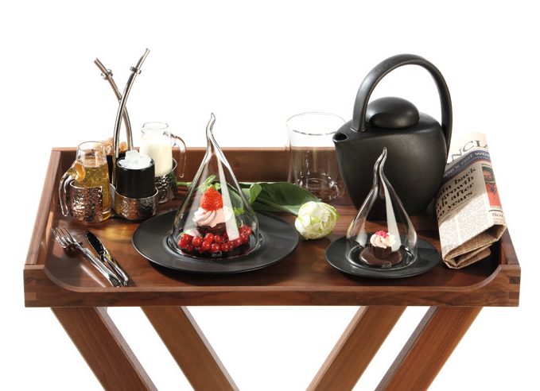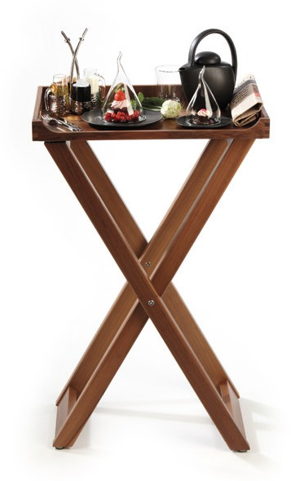Tray stand “Solid“

The tray stand of the series “Solid“ by ZIEHER convinces in every
aspect!

The shapely stand always provides the appropriate possibility to set up the “Solid“ room service tray (art no 4735) in the hotel room but also in the restaurant.

Combined with Zieher buffet platters in the format 2/1 GN the stand easily and flexibly creates new spaces at a comfortable height. As such it is predestined for the use at the buffet as well as for the use during coffee breaks in the congress and convention business.

The massive frame made of walnut wood harmonizes perfectly with other buffet items of the series and can be combined with them very well.

Anti-slip buffers on the top prevent the shifting of platters and trays, felt gliders at the base protect the parquet flooring and ensure safe standing.

WWW.ZIEHER.COM

03/2022
Zieher KG, Kulmbacher Straße 15, D - 95502 Himmelkron • marketing: +49 9273 9273-68 • presse@zieher.com
In our press area on www.zieher.com you will find all press releases including visual material to download.

