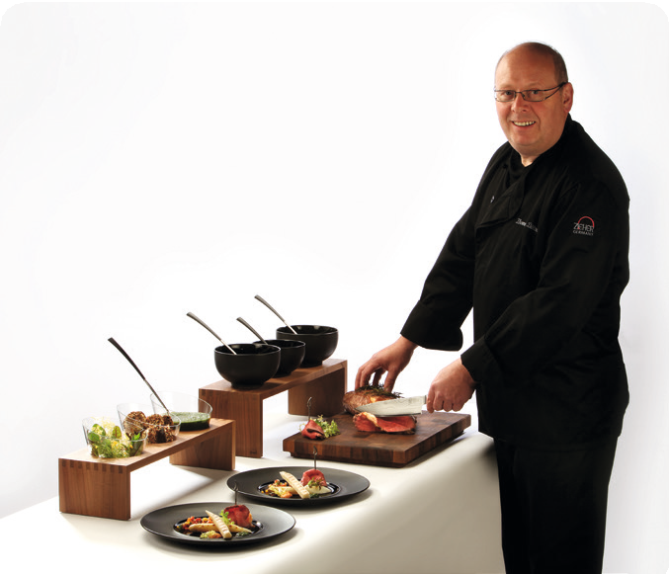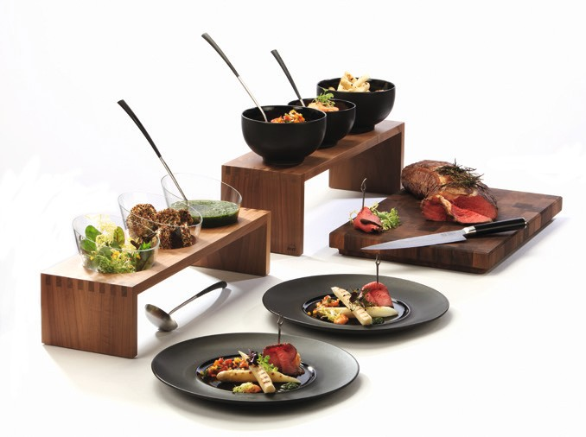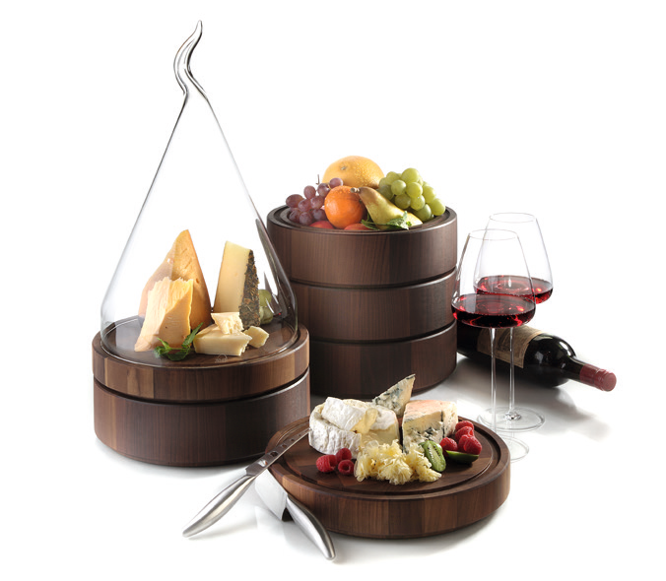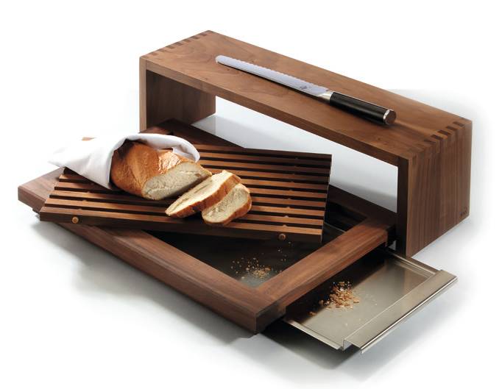“Solid”- Exclusive Cutting Boards and More!
TV cooking shows are in fashion.

Whether used for general catering, special events or at a hotel’s own buffet, the new Zieher cutting boards feature both attractive design and high functionality. Bowls can be placed either on top of
suitable bridges or can be hooked into fitted slots which ensures neat arrangement required for smooth work from behind the buffet.
The cutting boards‘ dimensions have been chosen in a way that two of them will find space in one customary transport box (60 x 40 cm). This facilitates easy storage and transport in everyday catering usage.

Apart from the classic cutting board made of solid end grain, Zieher offers a specific bread cutting board that comprises of a crumb collector and exchangeable grillage (available as spare part).

Massive walnut wood forms the raw material for the “Solid” series. It is known to be one of the most precious and most beautiful types of wood whose warm brown color gradations and intensive and distinctive grain make every single product unique! Zieher guarantees high durability even in everyday use due to highest- quality craftsmanship and food-safe sealing.

WWW.ZIEHER.COM

03/2022
Zieher KG, Kulmbacher Straße 15, D - 95502 Himmelkron • marketing: +49 9273 9273-68 • presse@zieher.com In our press area on www.zieher.com you will find all press releases including visual material to download.

